Partnership Pilot Frequently Asked Questions

Questions:
1. How are performance incentives determined per event? If there are no events, is the performance budget is 0? 2
2. If there are fewer than the maximum number of events, will the performance budget be proportional to the number of events or will the maximum budget be allocated? 2
3. What is the penalty structure for underperformance? 2
4. If a customer has gotten a deployment incentive for a given tranche, will they be ineligible for any deployment incentives in future tranches? 2
5. What is the timing of the disbursal of the funds from each of the deployment, reservation, and performance budgets each year? 2
6. How is performance calculated/what baseline is used? 2
7. Is performance data submitted by the Energy Service Provider (ESP) or will the PG&E calculate performance? 3
9. How can a Participant determine if a service account is in the eligible area? 3
10. Where can participants find data on the Rocklin 1105 circuit in the RAM map? 3
11. For the Coalinga 1 Bank 2 circuit, how do Participants obtain more information on the project requirements, including capacity need and event parameters? 4
12. When will the contracts be available for review? 4
13. Will PG&E provide the ESPs with sample customer affidavits or should Participants develop them internally? 4

1. How are performance incentives determined per event? If there are no events, is the performance budget is 0?
Answer: The performance budget is 50% of the total budget. If there are no events, that portion of the budget would not be paid to aggregators.

2. If there are fewer than the maximum number of events, will the performance budget be proportional to the number of events or will the maximum budget be allocated?
Answer: The price per event is fixed. If not all events are utilized, there will remaining performance budget. The disposition of any surplus budget will be addressed in future proceedings.

3. What is the penalty structure for underperformance?
Answer: The penalty structure will be addressed in the Partnership Pilot TNPF and will be similar to the payment structure in the Standard Offer Contract TNPF.

4. If a customer has gotten a deployment incentive for a given tranche, will they be ineligible for any deployment incentives in future tranches?
Answer: Deployment incentives will be awarded annually to projects that are incremental relative to an initial date. If the Aggregator is chosen for a future tranche, they would be eligible for a deployment payment for those projects that were deemed incremental initially.

5. What is the timing of the disbursal of the funds from each of the deployment, reservation, and performance budgets each year?
Answer: Deployment payments will be made after a licensed professional engineer certifies the project(s) has been built according to the contract between the aggregator and PG&E, and proof that it is capable of performing according to the contracted need. Reservation payments are made monthly, during the months listed in the contract, depending on the performance of the aggregator. Performance payments are made monthly depending on the number of calls made and the performance of the aggregator.

6. How is performance calculated/what baseline is used?
Answer: We will employ baseline methodologies similar to what is used in other programs, which may depend on the type of customers participating. The baseline is calculated using the same months and time periods in question from the previous year. For example, if the months the aggregator has subscribed to are July-August of 2024, the baseline would be the July-August of 2023.

7. Is performance data submitted by the Energy Service Provider (ESP) or will the PG&E calculate performance?
Answer: The IOU will assess the performance of the aggregator using metered data and the baseline energy methodology for the dispatch period.
8. How is performance determined for a multi-use resource, calculating incrementality? For Demand Response, can capacity that is contracted for certain months participate in other programs in other months if eligible?
Answer: Yes. Participants are free to use their resources however they see fit in non-contract months.

9. How can a Participant determine if a service account is in the eligible area?
Answer: The DIDF Data Access Portal (https://www.pge.com/b2b/distribution-resource-planning/grid-needs-assessment-map.html) is a good starting point. Participants can log in with existing PG&E credentials or create a new account. Search for the Partnership Pilot project of interest under the “Candidate Deferral” layer. The “Demand Forecast Scenario” layer and the “GNA Scenario” layer will provide additional locational information on the Grid Need deficiencies (i.e., performance requirements) associated with the Partnership Pilot project of interest. An example using Mormon Bank 2 is below. Please refer to the User Guide (link at the top right of the Access Portal page) for additional guidance on how to use the Data Access Portal.
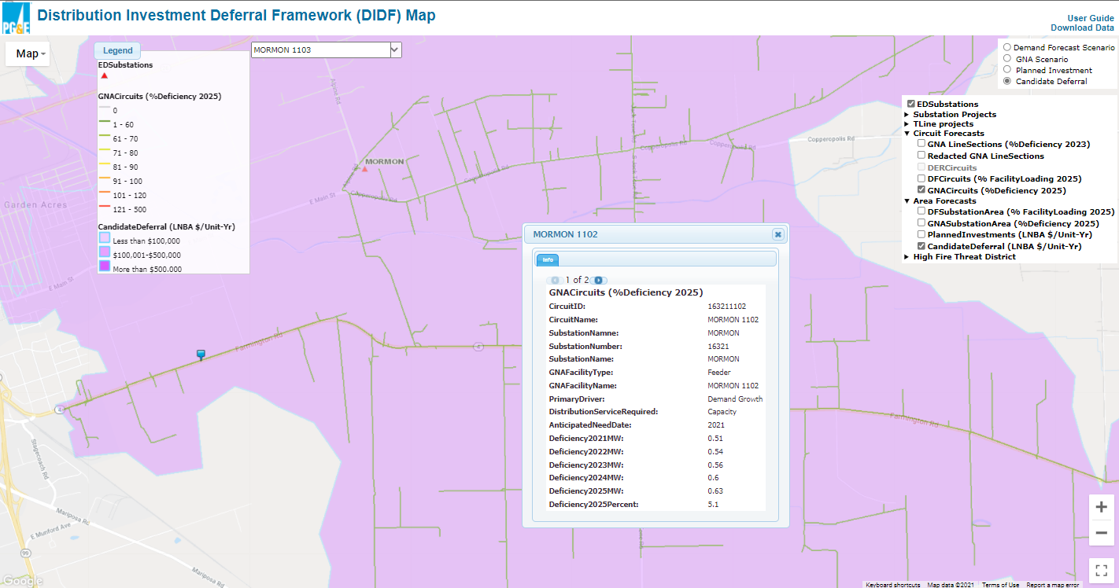

10. Where can participants find data on the Rocklin 1105 circuit in the RAM map?
Answer: Rocklin 1105 is a new feeder that has not been built yet. To defer the need for this project, the Grid Need at Del Mar Bank 2 should be met. Please note, customer information is always in respect to the Grid Need that is being addressed (not the name of the project).

11. For the Coalinga 1 Bank 2 circuit, how do Participants obtain more information on the project requirements, including capacity need and event parameters?
Answer: Participants must sign an NDA. Document coming soon to the Partnership Pilot webpage.

12. When will the contracts be available for review?
Answer: By the launch of the program. Expected launch is January 18, 2022.

13. Will PG&E provide the ESPs with sample customer affidavits or should Participants develop them internally?
Answer: PG&E will provide its affidavit as part of its subscription materials.

Suggested rephrase/delete:
Can the same capacity be participating in wholesale market PDR and get credit for capacity deferral? If so, how is performance measured if there are both distribution and market events? If so, how would the baseline (if applicable) be adjusted or not adjusted to account for market events that may impact performance assessment for the distribution deferral event
Answer: Please see the CPUC’s D.18-01-003 from 1/11/2018 Appendix A: Rule 1. Resources interconnected in the customer domain may provide services in any domain. Rule 2. Resources interconnected in the distribution domain may provide services in all domains except the customer domain, with the possible exception of community storage resources, per Ordering Paragraph 11 of D.17-04-039.
Will there be regular updates available on the amount of reserved capacity for each project before it has been fully subscribed?
Answer: Please see the CPUC’s D.21.02.006 Ordering Paragraph 8, page #80 that says the Commission orders “..a page on their company website that describes the Partnership Pilot, advertises the upcoming launch of the Pilot subscription and notices availability of procurement tranches within 30 days of tranche opening, identifies monthly updated Procurement Goals for each deferral opportunity, and provides notice that aggregators will be looking for customers to enroll in the Tariff Pilot and customers should revisit the webpage again by September 15....”.

- Why is the customer breakdown different on the RAM map versus the ICA map?
Answer: The ICA map is updated monthly, please use it for the most up-to-date information.
- Are the shapefiles in the DIDF map accurate enough to use for targeting customers?
Answer: We are currently working on updating the ‘substation area’ polygons in the shape file, so these polygons are a little out of date. However, the feeder and circuit lines in the shape file that displays on the map are up to date and can be used to target customers.

