Rate Year 2026 Annual Update

(December 1, 2025)

Protocols Section 4.3.1(5): Provide for the applicable Rate Year the following information related to affiliate cost allocations:
  - a detailed description of the methodologies used to allocate and directly assign costs between PG&E and its affiliates by service category or function, including any changes to such cost allocation methodologies from the Prior Year and the reasons for those changes
PG&E Corporation (Corporation) allocates its Administrative and General (A&G) expenses to PG&E. PG&E Corporation Support Services II, Inc. (PSP2) supports the Corporation and its affiliates. Therefore, 100% of PSP2 expenses are included in the A&G allocation from the Corporation to PG&E. The Corporation continues to provide oversight over its largely inactive remaining unregulated subsidiaries. There have been no significant changes to the cost allocation methodology from the Prior Year.
In general, PG&E’s Corporate Accounting team evaluates the A&G allocation in January each year to consider any changes in unregulated activities, cost centers and new entities. The Corporation will charge its allocable A&G expenses to its specified affiliates based on the methodology and summary below. This allocation will be modified in the future if unregulated activities increase.

Methodology
The Corporation performs services for its affiliates and allocates its charges based on the allocation rates below:
- Three-Factor Methodology:
It is the simple average of the following three ratios:
a. Affiliate Assets/Total Consolidated Assets
b. Affiliate Operating Expenses less Fuel purchase costs/Total Consolidated Operating Expenses less Fuel purchase costs
c. Affiliate Headcount/Total Consolidate Headcount
- Capitalization:
It is the ratio of affiliate’s capitalization over total consolidated capitalization. Capitalization includes long term debt, owner’s equity and retained earnings.
- Headcount:
It is the ratio of affiliate’s headcount over total headcount for all entities.

Summary
The 2024 Corporation A&G Allocation Rate is calculated below and will be rounded to 99% (Three-Factor Methodology and Headcount). The 99% A&G allocation rate is consistent with 2027 General Rate Case (GRC) filing.
1. Three-Factor Methodology – 99.99%
2. Capitalization – 100%
3. Headcount – 99.99%
All of the Corporation’s cost centers allocate charges are based on Three Factor Methodology, except for the following cost centers:
COST CENTER | Description | Allocation Approach
PCC 20036 | HOLD- Banking & Money Management | Capitalization
PCC 20039 | HOLD- Investments & Benefits | Headcount
PCC 20041 | HOLD- Investor Relations | Capitalization
PCC 20050 | HOLD-Senior VP Human Resource | Headcount

The non-utility affiliates methodology is used in the GRC. Below is the language used in the 2027 GRC.
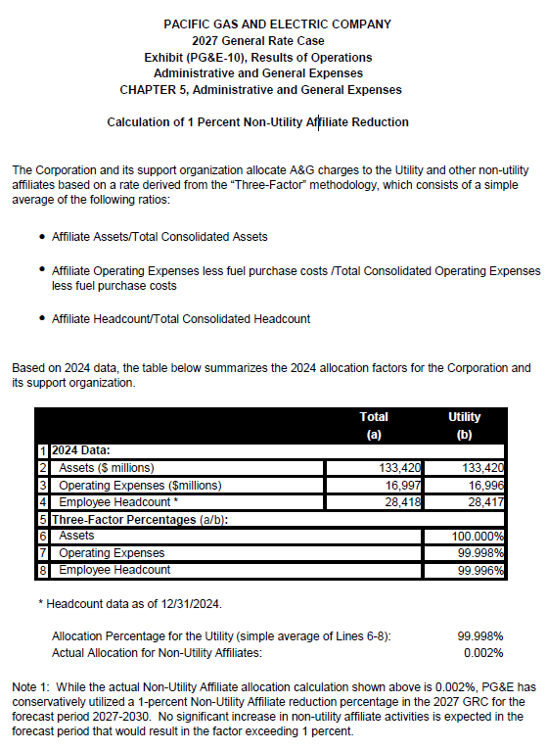
2. the magnitude of such costs that have been allocated or directly assigned between PG&E and each affiliate by service category or function
There is no change in the allocation methodology as described above.

See 2027 GRC, Exhibit (PG&E-10), Chapter 5 at 5-89.

