Cause Evaluator  Signature Date  Issue  Owner  Signature Date  Cause  Evaluation Report | 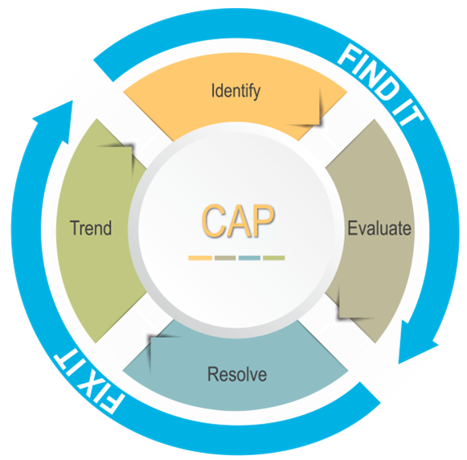  Title: Insert Here  Issue No.: Insert here CAP Issue No (PG&E Only)  Report Rev: 00

Complete and Send to EDContractorIncidentReporting@pge.com

Executive Summary

Problem Statement

Requirement or Expectation: (what was the desired outcome)

Deviation or Defect: (what was the deviation from the requirement)

Consequences of Deviation or Defect: (what was the consequence)

Significance of Deviation or Defect: (If not corrected, what is the potential impact)

Extent of Condition (Is it likely that the same condition currently exists undetected in other processes)

Event Description (Provide a chronological description of the facts and conditions that led to the problem)

Analysis

SME Evaluation (Who lead the evaluation):

Employee Interviews: (If available, include interviews of affected employees)

Training Review: (Affected employee training review)

Job Safety Review: (review applicable hazard identification, include as attachment)

Tailboard:

JHA- Job Hazard Analysis:

PSSP- Project Specific Safety Plan

Cause and Contributing Causes

Apparent Cause(s): (If there are multiple apparent causes, identify them as AC-1, AC-2, etc.)

AC-1:

NERC Cause Code: Refer to NERC Cause Code Reference Guide (attachment)

Contributing Cause(s): (If there are multiple contributing causes, identify them as CC-1, CC-2, etc.)

CC-1:

NERC Cause Code: Refer to NERC Cause Code Reference Guide (attachment)

Corrective Actions for Cause(s) and Contributing Cause(s)

Corrective Action Matrix
 | Cause(s) | CA # | CA Description | Action Owner | Due Date
C-1 | State each identified Cause from the report | CA-1 | State corrective action for the Cause
CC-1 | State each identified Contributing Cause from the report | CA-2 | State corrective action for Contributing Cause
 | -additional rows as needed

Attachments (Attachments could include photographs, charts, a timeline of the event, listing of people contacted during the investigation, as appropriate, Cause Evaluation Analysis tools, document references, and other supporting documentation)

