Enterprise Contractor Safety Plan Job‐Aid
Contents
Executive Summary 2
Background and Contractual Requirement 2
Keys to Life – Why This Matters to You 2
Who Needs to Complete a Safety Plan? 3
Programmatic vs. Project Specific Safety Plans 4
Where Should Safety Plans Be Submitted? 4
When Do Safety Plans Expire? 4
Who Completes Contractor Safety Plans? 5
Additional Resources for Hazard and Mitigation Content 5
Who do I contact with questions? 5
Steps to Complete a PG&E Safety Plan 6
General Information – All fields required for all Safety Plans 7
Section 1.0 General Information 9
Section 1.1 Field Leadership and Safety Oversight Plan 12
Section 1.2 General Personal Protective Equipment (PPE) Requirements 13
Section 2.0 Risk Assessment and Hazard Identification 14
Examples of Tasks/Hazard/Mitigation/Training for Section 2.0. 19
Section 3.0 Hazard Communication/Right to Know 21
Section 4.0 Emergency Action Plan 22
Section 5.0 Certifications and Licenses 23
Section 6.0 Managing Subcontractors 24
Section 7.0 Site Orientation 25
Section 8.0 Change Log 26
Section 9.0 Attachments 27
Environmental Remediation and Environmental Management Safety Plans 28
Definitions 30
Attachments 31
Revision Notes 31

Executive Summary
This document reviews the requirement for PG&E Contractors to create and maintain a Safety Plan, describes commonly referenced terms to clarify Programmatic versus Project Specific Safety Plans, and reinforces PG&E’s commitment to the pursuit that Everyone and Everything is Always Safe by including an emphasis on PG&E’s Keys to Life.

Background and Contractual Requirement
PG&E’s first and foremost goal is its Safety Stand that “Everyone and Everything is Always Safe.” This includes a commitment to our contractor partners to own our safety actions and risk outcomes, and work as a collaborative team to improve the safety of our internal employees, contractor partners, and the community we serve.

The creation and management of Contractor Safety Plans allows PG&E to collaborate with contractor partners so that the tasks, risks, and hazards of high-risk work are reviewed prior to the commencement of work. Robust Contractor Safety Plans that are the product of contractor and PG&E collaboration are pivotal in communicating to workers so that they understand their risks and hazards and the proper mitigations are put in place before work starts.

Per PG&E’s contract terms, in accordance with the Enterprise Contractor Safety Standard (SAFE-3001S), all contractors must provide a safety plan for high-risk work that fully addresses the scope-specific work to be performed. The safety plan must address the scope of work to be performed, the hazards associated with that work, and any training qualifications necessary to perform those tasks.

Keys to Life – Why This Matters to You
PG&E’s Keys to Life were first introduced in 2013 and slightly revised in 2021. The Keys to Life are now being shared with contractors to reinforce PG&E’s commitment to the goal of “Everyone and Everything is Always Safe.” It is a clear and direct commitment to encourage every PG&E partner to “Speak Up, Listen Up, and Follow Up.”

Each of these ten Keys to Life is a pivotal, unwavering component to working safely. They align with PG&E virtues to be Trustworthy, Empathetic, Courageous, Tenacious, Nimble, and to be Owners of our individual and community’s safety.

PG&E’s renewed commitment to Contractor Safety Plans ties directly with PG&E’s first Key to Life: “Conduct pre-job safety briefings prior to performing work activities.” By establishing our commitment to safety and reviewing the planned tasks and hazards before work begins, we are strengthening our commitment to the pursuit of keeping everyone and everything safe.

To learn more about the Keys to Life and how they align with PG&E’s virtues, visit the Enterprise Contractor Safety Website.

What is a Contractor Safety Plan?
Contractor Safety Plans are comprehensive reference documents for personnel in the field to perform work safely. They should cover the entire scope of work for the specific project or program and include work scopes performed by both prime and subcontractor partners. Developing these safety plans in advance of work allows PG&E to verify that contractor partners have identified and mitigated safety concerns and meet all applicable regulatory requirements.

This document reviews the steps to develop a Safety Plan that meets PG&E expectations. Safety Plans include comprehensive scopes of work, and the tasks, hazards, proper mitigation measures, and trainings needed to safety perform the identified work. Safety Plans also include a Management of Change process, safety contacts, and safety expectations, such as training attestations or minimum PPE requirements.

Contractor Safety Plan Requirements
The Enterprise Contractor Safety Website houses all Project Specific and Programmatic Safety Plans for PG&E contractor partners, including general PG&E templates, and specific Line of Business/Functional Area templates. Contractor partners who do not see the specific template for the line of business/functional area with whom they work should reach out to their Contractor Safety Specialist to request a template, or email ContractorSafetyInfo@pge.com.

Job Hazard Analyses (JHAs), Job Safety Analyses (JSAs), Job Site Safety Analyses (JSSAs), or similarly named documents are task specific and an integral part of an overall Safety Plan. JHAs describe, in detail, the task at hand, the hazards associated with the task, and the mitigations and trainings associated with the task. JHAs should also include site-specific information, or any changes to the task, method, or condition while performing the scope of work.

Although Safety Plans include a task section, Safety Plans and JHAs are not interchangeable. Each task should have its own standalone JHA. JHA templates are available on the Enterprise Contractor Safety Page, but do not need to follow the PG&E format.

Pre-Job Safety Briefings, or Tailboards, are the application of the Safety Plan and JHAs, and should distill and deliver the pertinent information to site personnel. These daily meetings should be led by competent PG&E or contractor personnel and are designed to communicate to the workforce the scope and responsibilities for the daily tasks. This allows the tailboard leader to focus the conversation and facilitate engagement from the field crew to gauge and drive understanding, set expectations, and communicate information on that day’s scope, tasks, hazards, and mitigations.

Pre-Job Safety Briefing information is available by request from your Contractor Safety Specialist, but do not need to follow the PG&E format.

Who Needs to Complete a Safety Plan?
All contractors must provide a safety plan for high-risk work that fully addresses the scope-specific work to be performed. Some lines of business or functional areas may also request Safety Plans for medium-risk work.

High-risk work is identified in the PG&E Enterprise Contractor Safety Risk Matrix and defined as work that requires specialized training, formal training, licensing, certification, or qualification.

When unsure of the risk level associated with current or upcoming work, reach out to your PG&E Project Lead or the Contractor Safety Specialist associated with the project’s line of business/functional area. The Enterprise Contractor Safety Team can help connect you to that contact, if needed.

All subcontracted work should fall within the overall Safety Plan for the proposed work scope. Subcontractors are still required to hold individual Tailboards/Pre-Job Safety Briefings and individual JHAs (see section above for definitions). Subcontractors can elect to create and follow their own Safety Plans if they: 1) Meet and exceed the prime contractor Safety Plans and 2) Are approved by the prime contractor.

Programmatic vs. Project Specific Safety Plans
All PG&E Safety Plans must address the scope of work to be performed, the hazards associated with that work, and any training qualifications necessary to perform those tasks. However, two versions of PG&E Safety Plans are available for contractors based on the type and frequency of work being performed.

Safety Plans can be Project Specific or Programmatic:

Project - A project refers to a specific, singular endeavor to deliver a tangible output. A project may be a stand-alone effort, or it may be part of an overarching program. At PG&E, a project is typically referred to as a ‘job,’ and work is typically performed at one location.
Example: Single pole replacement, generator replacement, environmental assessment of jobsite.

Programmatic - A program refers to multiple projects, across multiple locations, which are managed and delivered as a single package.
Example: Locate and mark services in Northern region, restoration services, etc.

Contractors should work directly with their PG&E Project Lead to determine if their work best fits under project or programmatic work. For project only work, a Project Specific Safety Plan (PSSP) should be completed that includes site-specific information (such as the location of the nearest hospital, location of eye wash stations on site, etc.). Work that is determined to be programmatic can fall under a Programmatic Safety Plan (PSP). If utilizing a PSP for non-location specific work, all site-specific information should be included in the Tailboard/Pre-Job Safety Briefing.

Note: Some lines of business/functional areas may require contractors to submit a Programmatic Safety Plan that broadly covers their entire potential scope of work in support of that functional area.

Project Specific Safety Plan (PSSP) and Programmatic Safety Plan (PSP) templates can be found on the PG&E Enterprise Contractor Safety Page. Some lines of business/functional areas have slightly edited versions of these templates available to contractors.

Where Should Safety Plans Be Submitted?
There is no central repository for Safety Plans; each line of business/functional area has developed individual processes best suited for their lines of work. Work with your PG&E Project Lead to determine the correct submission process.

All contractors can upload Programmatic Safety Plans (PSPs) to their ISNetworld account and are encouraged to do so. PSPs do not have an ISN grade component, but aid PG&E Contractor Safety Teams in determining the available scopes of work from our contractor partners.

When Do Safety Plans Expire?
Project Specific Safety Plans (PSSPs) expire at the conclusion of project work, following project close-out procedures. If the project is multi-year, the PSSP should be reviewed and renewed annually.

Programmatic Safety Plans (PSPs) expire annually. It is recommended that contractors complete PSPs in January to remain in compliance throughout the year. This also improves our Contractor Safety Team’s “End of Year Efforts” while removed from peak-season work.

Who Completes Contractor Safety Plans?
There is currently no minimum training or qualification for Contractor Safety Plan authors. Contractor Safety Plans should be authored by employees confident in the scope of proposed work, the associated hazards, and all required mitigations and trainings. It is recommended that Safety Plan authors work closely with the PG&E Project Leads, their company project or program leaders, subject matter experts (regarding the scope), and PG&E Contractor Safety Teams.

Additional Resources for Hazard and Mitigation Content
The PG&E Project Lead and PG&E Contractor Safety Teams are excellent collaboration partners and resources regarding the tasks, hazards, and mitigations needed for your PG&E project.

A variety of online resources exist for sample Safety Plans and JHAs, which can be referenced in the task/hazard/mitigation section of Contractor Safety Plans. The United States OSHA Page lists a variety of sample programs that can be referenced for details, and third-party companies and Subject Matter Experts (SMEs) can provide guidance.

Who do I contact with questions?
Enterprise Contractor Safety Team: ContractorSafetyInfo@pge.com

Steps to Complete a PG&E Safety Plan
Note: The steps below show screenshots of the Enterprise Contractor Safety Programmatic Safety Plan and the Enterprise Contractor Safety Project Specific Safety Plan. Your PG&E Project Lead may direct you to complete a slightly different template specific to that of line of business/functional area you are supporting.

Note: If completing a Safety Plan for Environmental Remediation or Environmental Management where you were instructed to create a Health and Safety Plan (HASP) “Bridging Document,” skip to the end of this Job Aid for specific instructions.

Note: If completing a Programmatic Safety Plan, the following sections are omitted, and section numbers are adjusted accordingly:
- Section 3.0 Hazard Communication/Right to Know
- Section 4.0 Emergency Action Plan
- Section 6.0 Managing Subcontractors
- Section 7.0 Site Orientation

General Information – All fields required for all Safety Plans
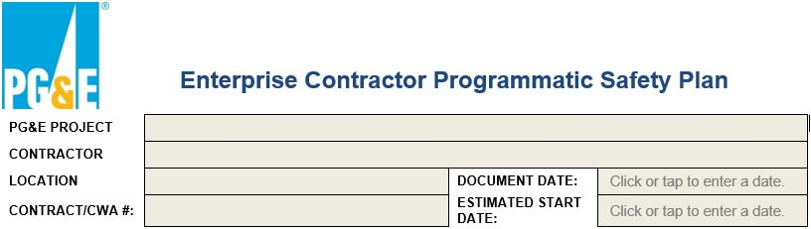

- Enter full project name – Make sure it is appropriate, utilizing language associated with an MSA or contract. For Project Specific Safety Plans, list the Project Number and/or Project ID if available.
  - Examples of Programmatic Titles include:
    - Routine Distribution, Routine Transmission, Emergency (wildfire), Traffic Control, Equipment delivery, etc.
- Enter full contractor name – Use full name as shown in ISNetworld and California State Business License
  - Include any alternative names or DBAs
- Location – For Programmatic Safety Plans (PSPs), enter the region(s) where work is being conducted for PG&E. For Project Specific Safety Plans, enter the work address or appropriate location as listed in the contract.
  - You can enter multiple regions in this field. Place a comma between each region if you worked in more than one region.
- Document Date – Enter the date that the Safety Plan was completed.
  - Note: some versions of Safety Plans have a “Click or tap to enter” option here, while others have an open text. If the “Click or tap to enter a date” is shown, click on the box, select the down arrow for the calendar tool to open. Once the calendar is open, select the day that the document is being completed.
- Estimated Start Date – Enter the estimated start date.
  - Note: some versions of Safety Plans have a “Click or tap to enter” option here, while others have an open text. If the “Click or tap to enter a date” is shown, click on the box, select the down arrow for the calendar tool to open. Once the calendar is open, select the day that the document is being completed.

- Contract/CWA # – This must be completed by both Prime & Subcontractors. Contracts typically start with a “C.”
  - Subcontractors should work with prime contractors to include the correct Contract/CWA if it is not available on their Subcontractor Work Agreement (SWA)

Section 1.0 General Information
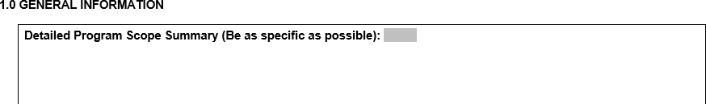
- Detailed Program Scope Summary – This field is required with every submission. Be specific describing the work being conducted. The scope may be copied from a PG&E contract, but must be descriptive and note the nature of work specifically.
  - Safety Plans are Line of Business/Functional Area specific. Only include the scope of work for the Line of Business/Functional Area specific to the Safety Plan being completed. Any activity for other lines of business will not be accepted in this section and will require resubmission.
  - Programmatic Safety Plans should be descriptive in the overall work being provided and include tasks that may not be present at every site.
  - Subcontractors: If you are a subcontractor, specify the prime contractor that you are conducting work for on behalf of PG&E.
  - Examples of information to include:
    - Identify contractor scope of work
    - Detail line of business activity being supported through the work
    - Discuss task being conducted (i.e. Rigging, Brush Clearing, Traffic Control, Inspection, working near energized lines, etc.…)
  - Examples of sufficient Detailed Program Scope Summary:
    - “Various High Risk, Routine and Repetitive Power Distribution Line Work or Projects as awarded by PG&E. Typical Scopes of Work (SOWs) examples for Distribution Overhead (OH) and Underground (UG) work may include primary or secondary pole replacement, OH conductor & UG cable replacement/ reconductoring, electrical equipment maintenance/ replacement (transformers, reclosers, capacitor banks, manual & SCADA switches, etc.)”
    - “The standard scope of work performed on behalf of PG&E covered by this plan includes Underground Gas/Joint Trench general construction and maintenance. This includes but is not limited to access road restoration/installation, power pole foundation installation, emergency response, excavation, and property restoration.”
    - “Traffic control services including onsite consultation and coordination of project with the customer (PG&E) as well as State, County, and City inspectors. Custom Traffic Plan design and submittal. Work zone capabilities that include lane closure, freeway/highway work, road closures/detours, and shoulder closures.”
  - Examples of insufficient Detailed Program Scope Summary:
    - “Electric Distribution work.”
    - “Construction work for Gas Operations, including excavation and trenching.”
    - Any copy and paste from contracts or other documents that broadly cover the company’s commitment to completing work and working safely, but do not clearly define the scope of work.

- Risk Level of Work – Check the box for either “Medium” or “High”. Only one box should be checked. If performing both high and medium risk work, select high risk.
  - If you are unsure which risk level applies, contact your PG&E Project Lead or your Contractor Safety Team.
.
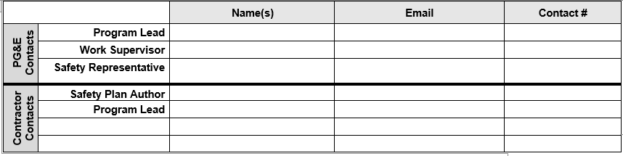
- PG&E Program / Project Lead – This individual is the internal PG&E Lead over the region(s), project, or program being supported. **Email and Contact # should be included with every submission**
  - Program or Project Leads should have a leadership role, but may hold various titles based on the work type or Functional Area.
    - Examples of leadership titles and representatives to be included in this section include Project Managers listed on the contract, Construction Managers, or Directors.
    - Program and Project Leads should be specific to the Safety Plan’s Line of Business/Functional Area.
  - If you work in multiple regions, you must include the proper Program/Project Lead for each region OR a director-level position that oversees the entire program/project.
- PG&E Work Supervisor – This individual is the internal PG&E Supervisor over the region(s), project, or program being supported. **Email and Contact # should be included with every submission**
  - Work Supervisors should have direct oversight to the work and act as onsite representatives but may hold various titles based on the work type or Functional Area.
    - Examples of titles and representatives to be included in this section include Managers, Supervisors, or Foremen.
    - Work Supervisors should be specific to the Safety Plan’s Line of Business/Functional Area.
  - For Programmatic Safety Plans that do not have consistent Work Supervisors, use your best judgement to include PG&E representatives that regularly work with or supervise your teams.

- PG&E Safety Representative – This will be the Contractor Safety Team member and/or Field Safety Specialists for the region being supported.
  - If you work in multiple regions or Functional Areas, include multiple contacts in this section.
  - If you are unsure of who your Safety Representative is, reach out to the Enterprise Contractor Safety Team at ContractorSafetyInfo@pge.com or your PG&E Project Lead
- Contractor Contacts – You know your business best! If there are additional individuals that should be included, make sure you list their name, email, and phone number. There is room for additions to this table. Minimal requirement is a Safety Plan Author and Program Lead. **Email and Contact # should be included with every submission**
  - This is pivotal for Safety Plan collaboration. Examples of additional contacts may include lead foremen, work supervisors, Safety Leads, or Leadership members.

Section 1.1 Field Leadership and Safety Oversight Plan

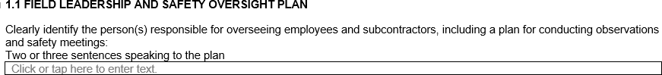
.’]=h

- Field Leadership and Safety Oversight Plan – Brief explanation covering the below topics:
  - Field Safety point of contacts (Name, Email, Phone), even if previously listed above.
  - Field Operations Leaders that own safety outcomes of employees and/or subcontractors, even if previously listed above.
  - How do you work to promote that everyone, and everything is always safe?
  - How will you conduct Safety Connections (observations/meetings) to promote employee and/or subcontractor compliance of work safety with all applicable standards and regulations?
  - Reference your ISNetworld Safety Observation Program here!
  - Example below:
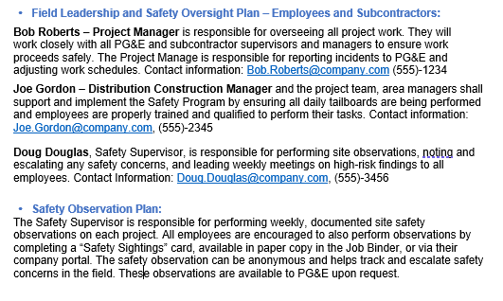

Section 1.2 General Personal Protective Equipment (PPE) Requirements
- No contractor additions are required here. If your company has additional, standard PPE requirements, you are welcome to include them here.
- This section lists minimum PPE equipment required at a jobsite, as pertinent to the Scope of Work listed in section 1.0
- Additional PPE Requirements required by contractor safety program, PG&E Contract, or pertinent industry standards not covered in the list below can be provided in section 2.0 of the form.
  - Examples of Contractor Safety required items could include Walking sticks for Pre-Inspectors, Chainsaw Chaps for Tree Workers, etc.…
- Task specific PPE such as rubber gloves, hard toes, etc.… can be identified in section 2.0

7

Section 2.0 Risk Assessment and Hazard Identification
- Hazard identification must be performed for the anticipated work scope.
- Utilize the Energy Wheel to identify and focus on the High Energy Hazards that are expected for the scope of work. High energy hazards are also known as STKY’s, or “Stuff That Kills You,” and are most likely to cause a SIF if an employee contacts the high energy.
- Establish Essential Controls, where possible, in the “Contractor’s Mitigation Plan” column. An Essential Control is a physical safeguard that is: (1) Specifically targeted to the high-energy source, (2) Effectively mitigates exposure to the high-energy source when installed, verified, and used properly, (3) Is effective even if there is unintentional human error during work that is unrelated to the installation of the control.
- For more information on High Energy Hazards and Essential Controls, see the PG&E Contractor Safety Handbook and Edison Electric Institute’s Safety Classification and Learning Model reference documents.
- The below table includes this information as a reminder that High Energy Hazards and Essential Controls must be considered for each Safety Plan. It also includes definitions/triggers for High Energy Hazards.
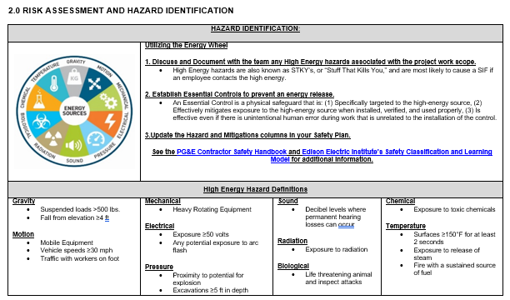

- The table shown below is intended to provide examples of hazards while performing work for PG&E. This is for guidance only and not intended to be changed. Some contractors choose to highlight the tasks and hazards that apply to their scope here to assist in completing their hazard analysis, but it is not required.

HAZARD IDENTIFICATION: The hazards encountered as part of this scope could include, but are not limited to:
GENERAL HAZARDS  - Uneven Ground/ Slips/ Trips & Falls  - Confined Spaces  - Driving  - Power Tool / Equipment Use  - Ergonomics  - Loading / Off-loading Equipment and Material  - Unstable Ground Conditions / Slopes / Uneven terrain  - Safety-At-Heights / Scaffolding / Ladders  - Cave-ins/ Excavating / Trenching / Shoring  - Suspended Loads  - Welding / Oxy Acetylene / Grinding  - Hot work  - Aggressive Animals / Dogs / Etc.  - High Crime Areas  - Access  - No Cell Service  - Night Operations  - Wildfire Safety  - Dropped Objects  HEALTH HAZARDS  - Chemical Exposure / Burns  - Noise Exposure  - Pesticides / Fumigation  - PCB / Lead / Mercury  - Asbestos  - Other Soil Contaminants  - Hazardous Material Transportation  - Hazardous Waste Transportation  - Radioactive Exposure | PUBLIC SAFETY  - Distracted, Impaired, Unsafe Motorists  - Vehicular Traffic (Work Area Protection)  - Pedestrian Traffic  - Proximity to Railroads  - Neighboring Facilities/Homeowner Issues  EXCAVATION  - Access / Proximity to Energized Equipment Proximity to Energized Circuits  - OH/UG Energized Lines  - Overhead Objects  - Appropriate Tools & Equipment  - Equipment Certifications  - Blasting Safety / Certification  - Confined Space  - Open Excavation / Fall Restraint  - Soil Type / Conditions / Shoring / Sloping  - Slopes / Terrain  - Spoil Management  - USAs  GAS HAZARDS  - Oxygen Deficient Atmosphere  - Explosive Atmosphere - Burns / Explosions  - Clearance Procedures / LOTO  - Dig-Ins / Line Strikes  - Unmarked or Mismarked Utilities | CRANE  - Crane Capacity  - Crane Size  - Load Weight  - Lift Plans  - Traffic / Transport  - Setup/Access  - Stability / Terrain  - Rigging  - Cribbing  - Dangerous Operations  - Equipment Certification  - Operational Certification  - Electrical Hazards  - Equipment Grounding  - Clearance  - Environmental issues  - Suspended Loads  - Weather Conditions  TRAFFIC CONTROL  / FLAGGING  - Environmental Conditions  - Non-Compliant Drivers  - Pedestrian Safety  - Permits  - Public Safety  - Qualifications / Certifications  - Site Specific Hazards  - Traffic Control Plan  - Low Light Conditions  - Weather  - Work Site Protection | ELECTRICAL HAZARDS  - Clearance Procedures / LOTO / Grounding  - Underground / Overhead Utilities  - Proximity to Energized Equipment  - Induction  - Energized Work  AVIATION  - External Cargo  - Landing Zone Safety  - Rigging  - Suspended Loads  - Flying in a Wire Environment  ENVIRONMENT HAZARDS  - Weather Conditions  - Poison Oak  - Animals / Insects  - Heat Illness  - Working Near/Over Water  MOTOR VEHICLE SAFETY  - Driving  - Backing  - Mountain Terrain  - Rural Roads  - Traffic  - Transporting Loads/Cargo  - Trailering/Towing  - Inclement Weather Driving  - Impaired Driving  - Distracted Driving

8

The second table in section 2.0 is where you will describe the tactical implementation of your safety programs, standards, and procedures.
Utilize the Job Hazard Analysis table in this section to describe critical tasks, associated hazards, mitigations, and training required to perform work safely.
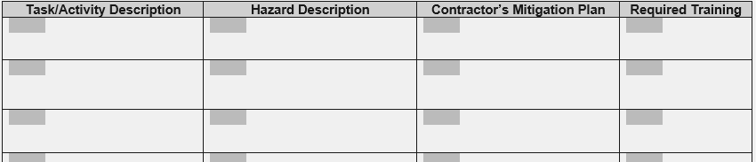
- Task/Activity Description – In these fields you will input the following pieces of information:
  - Critical task of activity being performed by employees and/or subcontractors for PG&E. Note: only critical tasks are to be listed, you are not required to list every task being conducted.
  - Critical tasks are those where the risk is rated as “medium” or “high” with a potential for serious injury or fatality.
  - Examples of high-risk tasks include but are not limited to live-line electrical work, working at heights, driving, and excavation.
  - Example of low-risk tasks that are not required to be listed in Safety Plans, but should be included in daily Tailboards and JHAs, include biological hazards (such as bug bites) or hand tool usage.
  - Additional tasks that should be listed in Safety Plans, if applicable, include;
    - Driving to and from site
    - Slips Trips and Falls
    - Working near schools, railroads, or other public safety concerns
    - Fire Protection & Mitigation
    - Working in remote locations

- Hazard Description – Task/Activity Description – In these fields you will input the following pieces of information:
  - Describe the hazards workers may be exposed to while performing the task/activity. The grey, hazard table at the beginning of Section 2.0 can be referenced here.
  - Examples include:
    - While driving, coworkers can be exposed to cognitive, mechanical, and visual distractions.
    - Other worker driving hazards include but are not limited to aggressive drivers, poor road conditions, road construction, traffic backups, pedestrian traffic, bicycles, etc.…
    - While performing Live Line Electrical Work, coworkers are in proximity to high voltage and are at risk of electrical contact.
    - While working at heights, coworkers are exposed to fall hazards and at risk of serious injury or death.
- Contractor’s Mitigation Plan – Next to each Hazard Description, describe how each hazard will be controlled. **Be Specific**
  - Examples include
    - While driving, coworkers are required to plan their route ahead of time and refrain from using electronic devices of any kind, except for on-board navigation systems.
    - While performing Live Line Electrical Work, coworkers are required to wear rubber protective gloves and sleeves in addition to following a company’s Live-Line work.
    - While working at heights, coworkers are required to utilize the appropriate fall protection in accordance with company standards and procedures.

- Required Training – Next to each Mitigation Plan, list the specific training your company provides or the specific training your company validates each coworker has completed to perform each task safely. **Be Specific**
  - Trainings can be internal to your company, PG&E specific trainings offered through ISNetworld or other platforms, or third-party qualifications and certifications.
  - Examples include:
    - Before any coworker is allowed to operate a vehicle, they must possess a valid driver’s license and pass a new driver assessment administered by a company representative.
    - Before any coworker is allowed to perform Live-Line work, they must possess the appropriate qualifications and pass a knowledge and skills assessment administered by a company representative.
    - Before working at heights, each coworker must pass the company fall protection training course, and demonstrate proficiency in selection, and wearing the appropriate PPE.
- Required Tasks, Hazards, and Mitigations
  - All Contractor Safety Plans, including PSPs and PSSPs, must include the following tasks and their associated hazards, mitigations, and trainings. Safety Plans without these tasks will be rejected unless validated as non-applicable by the PG&E Program/Project Lead.
    - General Site Safety (such as Slips/Trips/Falls, Uneven Ground, etc.)
    - Driving Safety
      - Rollover Prevention and Journey Management must be included in all high-risk safety plans where driving is part of the contractor’s scope
      - The goal of Journey Management is to prevent high-risk journeys from ever occurring in the first place.
      - A required component of Journey Management is Trip Risk Assessments. Trip Risk Assessments are performed on the day of travel. The goal is evaluating the immediate risks: Are the weather and road conditions suitable? Is the driver’s cell phone or satellite device adequately charged? Is the load properly secured? How many hours has the driver been on duty?
      - If the employees are embarking a high-risk journey, ensure there is a proper approval workflow in place to evaluate the necessity of the trip.
      - Journey Management Plans for each daily activity/route should be documented and made available to PG&E upon request. These may be integrated into your JSA, Tailboard, or other existing company documents.
      - Rollover prevention shall be considered: capabilities/experience of operator, appropriate vehicle selection, understanding center of gravity, load balancing, presence of trailer, braking system functionality and operation, and route selection.
    - For assistance on completing the hazards, mitigations, or training for the above required tasks, reach out to your PG&E Program/Project Lead.

Examples of Tasks/Hazard/Mitigation/Training for Section 2.0.

Note: Contractors are responsible for developing their own mitigation plans for the hazards expected onsite. This example is designed to be a frame of reference only for the level of detail that PG&E requests when performing Safety Plan Reviews.

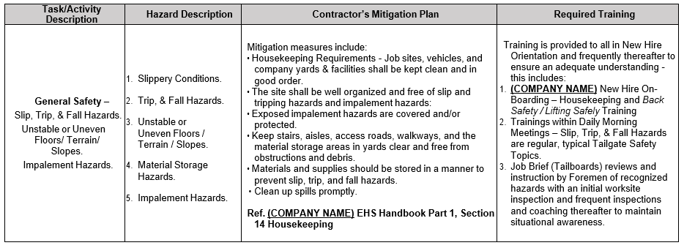
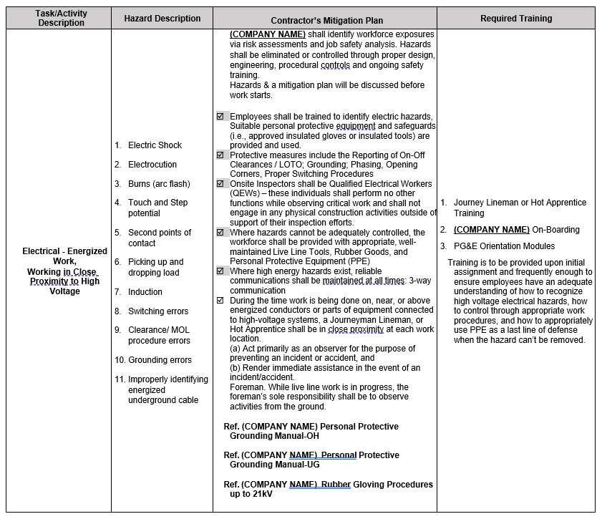

Section 3.0 Hazard Communication/Right to Know
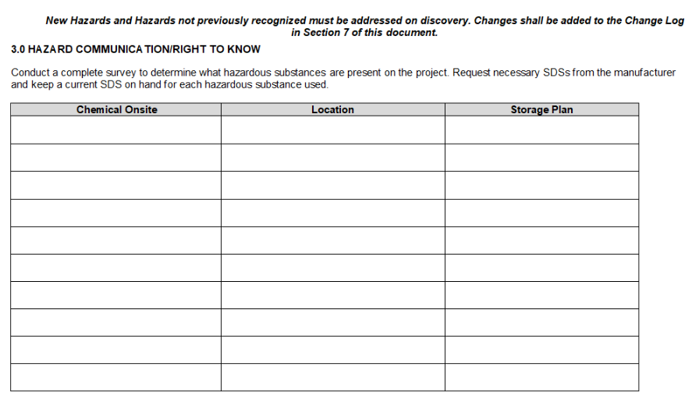
- This section is only required of Project Specific Safety Plans and is not included in Programmatic Safety Plans.
- In this section, note all hazardous substances with the potential to be present on the project site, their location, and a brief storage plan.
- This section should continue to be updated as new materials are purchased or identified onsite.
- If no hazardous chemicals are expected to be onsite, enter “No Hazardous Chemicals Onsite."

Section 4.0 Emergency Action Plan
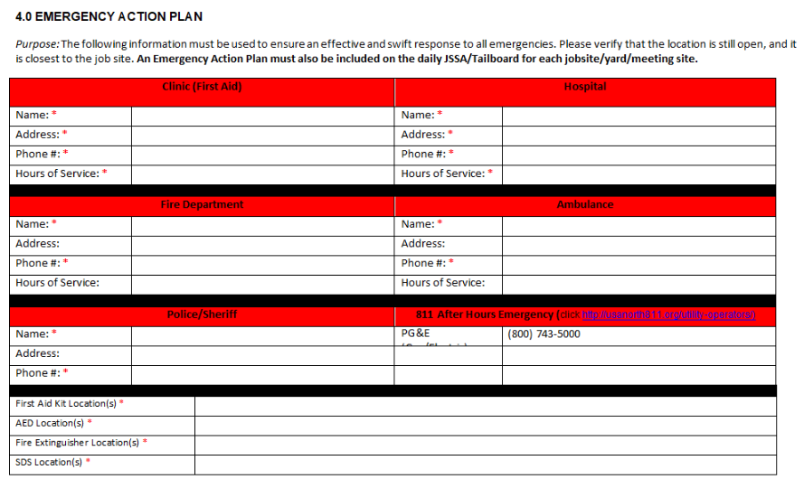
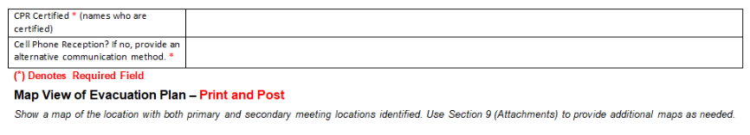
- This section is only required of Project Specific Safety Plans and is not included in Programmatic Safety Plans.
- In this section, complete all fields with a red *
- Confirm that the listed resources provide the appropriate services for the hazards that may be onsite.
  - Example: The nearest hospital should have an emergency center, not just a medical center where patients make appointments.
  - Example: If performing excavations, contact local fire departments to determine what resources are available for cave-ins or excavation failures.
- This section should continue to be updated if the project location changes.
- Note: Some projects may require more robust Emergency Action Plans due to the scope of work, remote locations, or risk associated with the project (such as gas storage facilities, hydro and generation facilities, etc.) Work with your Line of Business/Functional Area Contractor Safety Specialists and your Project Leads to determine the correct level of detail to include in Emergency Action Plans if requested.

Section 5.0 Certifications and Licenses
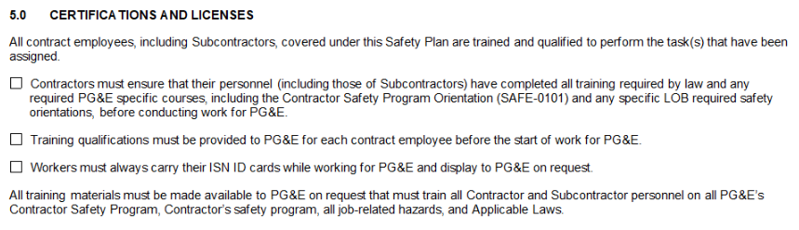
- In this section you must validate (by checking each box) that all contract employees, including subcontractors, are covered under this Safety Plan, and are trained and qualified to perform the task(s) assigned to them.
- Each box must be checked otherwise this section will be considered incomplete and resubmission will be required.

Section 6.0 Managing Subcontractors
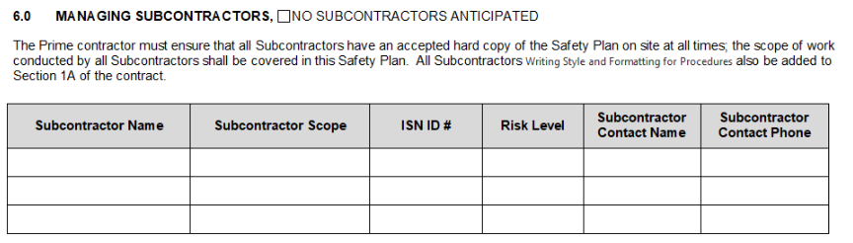
- This section is required of all Project Specific Safety Plans but is not required for Programmatic Safety Plans.
- If no subcontractor work is anticipated, the check mark at the title should be selected.
- Include subcontractors of all risk level and tier here, adding rows if needed. The Exhibit 1A form attached to your contractor should be referenced.
  - If there are changes to the use of any subcontractor at any tier, this section should be updated, reflected in the Change Log, and an updated Exhibit 1A should be submitted to the PG&E Contracts Management owner of the project.
- If no subcontractors are expected to be onsite, enter “No Subcontractors Utilized” and check the box next to the sub header.

Section 7.0 Site Orientation
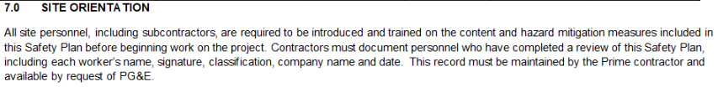

- This section is required of all Project Specific Safety Plans but is not required for Programmatic Safety Plans.
- Documentation can be done using a sign-in sheet onsite and should include all personnel including subcontractors.

Section 8.0 Change Log
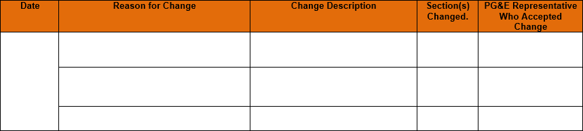

- Change log is for all changes between Safety Plan Reviews. Once the Safety Plan is approved (annual for Programmatic Plans or before work commences for Project Specific Plan), this section should be used to track any changes to onsite details.
  - Examples include changes to PG&E or contractor contacts, additional tasks or hazards identified onsite and their new mitigations, or changes to the overall scope of work.
  - This is a living document for all changes. Changes should also be reflected in the Daily Tailboard and any applicable JHAs covering the daily work.

Section 9.0 Attachments
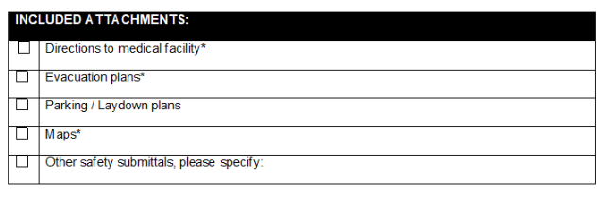
- Table shown above is just an example. Each PG&E Line of Business/Functional Area may have specific requirements for attachments based on their scope of work.
  - This section should include names of additional documentation that is applicable to the jobs being conducted. Any documents listed in this section must also be included to the end of this document along with a checkmark next to each attachment name. Failure to do so will result in delays and/or resubmission.
  - Examples include: IIPP, HIPP, Remote Work Policy, Fatigue Management Plans, etc.…
  - The above documentation may not be applicable to Programmatic Safety Plans.

Environmental Remediation and Environmental Management Safety Plans
- PG&E Environmental Remediation (ER) and Environmental Management (EM) have additional compliance requirements to comply with the California Code of Regulations and internal PG&E standards.
- Environmental Remediation (ER) requires HASPs (Health and Safety Plans) for all medium and high-risk work.
- Environmental Management (EM) requires HASPs for all high-risk work. Approval of HASPs for medium-risk work is not required, but medium-risk HASPs shall be submitted for documentation purposes.
- Project work subject to California Code of Regulations Title 8 § 5192 Hazardous Waste Operations and Emergency Response is high-risk per SAFE-3001P-17 (and SAFE-3001S) and, therefore, requires a PG&E approved HASP for both PG&E ER and EM projects.
- For work identified above that requires a HASP, contractors are required to complete PG&E’s Safety Plan template as a “Bridging Document.” The bridging document catalogues where key safety sections can be found in the contractor’s HASP (i.e., where this information may be found). This process promotes consistency across the enterprise and aligns safety plans to house the minimum required information.
- Specific questions regarding the use of the Safety Plan as a “Bridging Document” should be directed to ERSafetyCompliance@pge.com for ER projects or LEMContractorSafety@pge.com for EM projects
- Guidance for Bridging HASP information to PG&E Contractor Safety Plans is below. Additional information, including the submittal process, can be found in the Environmental Remediation Health and Safety Plan Submittal: Guidance Update and Best Practices (available via email from ER or EM Teams).

Section | Guidance
General Information | Follow all steps listed above to include project details.
Section 1.0 General Information | Contractors may elect to copy the scope of work from their HASP, or directly reference the applicable sections of the HASP.  Example: See Pages 12 and 13 of 760 of the HASP  Follow all steps listed above to include PG&E and Contractor contacts.
Section 1.1 Field Leadership and Safety Oversight Plan | Contractors may elect to copy this section from their HASP, or directly reference the applicable sections of the HASP.  Example:  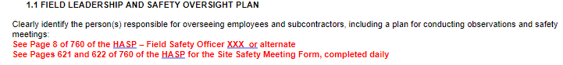
Section 1.2 General Personal Protective Equipment (PPE) Requirements | No contractor additions required.
Section 2.0 Risk Assessment and Hazard Identification | Contractors may elect to copy this section from their HASP, or directly reference the applicable sections of the HASP.  Example:  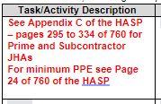  NOTE: The Risk Assessment Section must meet the minimum quality requirements outlined in the above Job Aid. See above sections for hazard analysis and mitigation examples.
Section 3.0 Hazard Communication/Right to Know | Contractors may elect to copy this section from their HASP, or directly reference the applicable sections of the HASP.  Example:  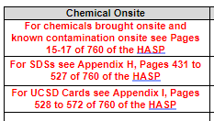
Sections 4.0 - 9.0 | Contractors may elect to copy these sections from their HASP, or directly reference the applicable sections of the HASP.

Definitions

Contractor – Company directly hired by PG&E to complete a specific scope of work or service. This term also applies to all subcontractors, at any tier, that have been retained by a primary PG&E contractor to provide a service for PG&E related project or programmatic work

Contractor Safety Specialist / Team – PG&E representatives responsible for supporting contractors with administrative and safety tasks, such as ISNetworld grades, onsite observations, and other compliance requirements. Each Functional Area / Line of Business has dedicated Contractor Safety Specialists and Teams. Contractor Safety Specialists may be referred to as Field Safety Specialists.

Functional Area (Formerly Line of Business) - PG&E has structured its diverse operations into Functional Areas, previously referred to as Lines of Business. These Functional Areas allow discrete, dedicated groups to provide support in the manner that best correlates to their operational needs. Functional Area examples include Gas Operations, Electric Distribution, Environmental Remediation, Vegetation Management, IT, and Hydro.
- Note: Functional Areas refer to the operation of the PG&E group that owns the work contract and may not directly correlate with the scope of work being performed by the contractor. For example, a contractor may be performing tree-trimming activities near a PG&E substation. Although the scope of work is “vegetation management” by definition of the work, the project is owned and managed by the Electric Substation Functional Area. Contractors who are unsure of their project’s Functional Area should contact their PG&E Project or Program Lead, or their PG&E Contract Owner.

JHA – Job Hazard Analysis. May be referred to as Job Safety Analysis (JSA) or Jobsite Safety Analysis (JSSA). JHAs describe, in detail, the task at hand, the hazards associated with the task, and the mitigations and trainings associated with the task. Each task (or group of tasks) should have a separate JHA. JHAs should also include site-specific information, or any changes to the task, method, or condition while performing the scope of work.

Keys to Life – PG&E’s ten commitments to the pursuit that “Everyone and Everything is Always Safe.” The first Key to Life is to “conduct pre-job safety briefings prior to performing work activities.”

Pre-Job Safety Briefing/Tailboard - Application of the Safety Plan and JHAs and should distill and deliver the pertinent information to site personnel. These daily meetings should be led by competent PG&E or contractor personnel and are designed to communicate to the workforce the scope and responsibilities for the daily tasks.

Programmatic Work - A program (or programmatic work) refers to multiple projects, across multiple locations which are managed and delivered as a single package.

Programmatic Safety Plan (PSP) – Safety Plan that covers only programmatic work scopes. Must include the full program’s scope of work, but does not require site-specific information such as the location of the nearest hospital, location of eye wash stations, etc.

Project / Program Lead – Individual with oversight and/or ownership responsibilities for a specific project (or program). Project Leads may hold various titles based on project types and Functional Areas, and can include (but are not limited to) Project Managers, Construction Managers, Directors, etc.

Project Work - A project refers to a specific, singular endeavor to deliver a tangible output. A project may be a stand-alone effort, or it may be part of an overarching program. At PG&E, a project is typically referred to as a ‘job,’ and work is typically performed at one location.

Project Specific Safety Plan (PSSP) – Safety plan that covers project work scopes. Formally referred to interchangeably with Site Specific Safety Plans (SSSPs). Must include the full project’s scope of work and all site-specific information such as the location of the nearest hospital, location of eye wash stations, etc.

Safety Plan - Comprehensive reference documents for personnel in the field to perform work safely. They should cover the entire scope of work for the specific project or program and include work scopes performed by both prime and subcontractor partners.

Subcontractor - Subcontractors are contractors that have been retained by a prime contractor to provide services on behalf of PG&E.

Work Supervisors – Individual with direct oversight to the work and act as onsite representatives. Work Supervisors may hold various titles based on project types and Functional Areas and can include (but are not limited to) Managers, Supervisors, or Foremen.

Attachments

Form 1: Enterprise Contractor Project Specific Safety Plan (Template)

Form 2: Enterprise Contractor Programmatic Safety Plan (Template)

Form 3: Enterprise Project Specific Safety Plan Enterprise Example

Form 4: Enterprise Programmatic Safety Plan Enterprise Example

Revision Notes

Where? | What Changed?
Section 2.0 Risk Assessment and Hazard Identification | - Required Tasks, Hazards, and Mitigations  - All Contractor Safety Plans, including PSPs and PSSPs, must include the following tasks and their associated hazards, mitigations, and trainings. Safety Plans without these tasks will be rejected unless validated as non-applicable by the PG&E Program/Project Lead.  - General Site Safety (such as Slips/Trips/Falls, Uneven Ground, etc.)  - Driving Safety  - Rollover Prevention and Journey Management must be included in all high-risk safety plans where driving is part of the contractor’s scope  - The goal of Journey Management is to prevent high-risk journeys from ever occurring in the first place.  - A required component of Journey Management is Trip Risk Assessments. Trip Risk Assessments are performed on the day of travel. The goal is evaluating the immediate risks: Are the weather and road conditions suitable? Is the driver’s cell phone or satellite device adequately charged? Is the load properly secured? How many hours has the driver been on duty?  - If the employees are embarking a high-risk journey, ensure there is a proper approval workflow in place to evaluate the necessity of the trip.  - Journey Management Plans for each daily activity/route should be documented and made available to PG&E upon request. These may be integrated into your JSA, Tailboard, or other existing company documents.  - Rollover prevention shall be considered: capabilities/experience of operator, appropriate vehicle selection, understanding center of gravity, load balancing, presence of trailer, braking system functionality and operation, and route selection.  - For assistance on completing the hazards, mitigations, or training for the above required tasks, reach out to your PG&E Program/Project Lead.
Section 2.0 Risk Assessment and Hazard Identification | - Utilize the Energy Wheel to identify and focus on the High Energy Hazards that are expected for the scope of work. High energy hazards are also known as STKY’s, or “Stuff That Kills You,” and are most likely to cause a SIF if an employee contacts the high energy.  - Establish Essential Controls, where possible, in the “Contractor’s Mitigation Plan” column. An Essential Control is a physical safeguard that is: (1) Specifically targeted to the high-energy source, (2) Effectively mitigates exposure to the high-energy source when installed, verified, and used properly, (3) Is effective even if there is unintentional human error during work that is unrelated to the installation of the control.  - For more information on High Energy Hazards and Essential Controls, see the PG&E Contractor Safety Handbook and Edison Electric Institute’s Safety Classification and Learning Model reference documents.  - The below table includes this information as a reminder that High Energy Hazards and Essential Controls must be considered for each Safety Plan. It also includes definitions/triggers for High Energy Hazards.

