Partnership Pilot Frequently Asked Questions

QUESTIONS:
1. How are performance incentives determined per event? If there are no events, is the performance budget 0? 2
2. If there are fewer than the maximum number of events, will the performance budget be proportional to the number of events or will the maximum budget be allocated? 2
3. What is the penalty structure for underperformance? 2
4. If a customer has gotten a deployment incentive for a given tranche, will they be ineligible for any deployment incentives in future tranches? 2
5. What is the timing of the disbursal of the funds from each of the deployment, reservation, and performance budgets each year? 2
6. How is performance calculated/what baseline is used? 2
7. Is performance data submitted by the Energy Service Provider (ESP) or will the PG&E calculate performance? 2
8. How is performance determined for a multi-use resource, calculating incrementality? For Demand Response, can capacity that is contracted for certain months participate in other programs in other months if eligible? 3
9. How can a Participant determine if a service account is in the eligible area? 3
10. Where can participants find data on the Green Valley Bank 4 or Camden 1106 circuits in the DIDF map? 3
11. For the Giffen Bank 2 project, how do Participants obtain more information on the project requirements, including capacity need and event parameters? 4
12. Will there be regular updates available on the amount of reserved capacity for each project before it has been fully subscribed? 4

1. How are performance incentives determined per event? If there are no events, is the performance budget 0?
Answer: The performance budget is 50% of the total budget. If there are no events, that portion of the budget would not be paid to aggregators.

2. If there are fewer than the maximum number of events, will the performance budget be proportional to the number of events or will the maximum budget be allocated?
Answer: The price per event is fixed. If not all events are utilized, there will remaining performance budget. The disposition of any surplus budget will be addressed in future proceedings.

3. What is the penalty structure for underperformance?
Answer: The penalty structure will be addressed in the Partnership Pilot Distribution Services Agreement.

4. If a customer has gotten a deployment incentive for a given tranche, will they be ineligible for any deployment incentives in future tranches?
Answer: Deployment incentives will be awarded annually to projects that are incremental relative to an initial date. If the Aggregator is chosen for a future tranche, they would be eligible for a deployment payment for those projects that were deemed incremental initially.

5. What is the timing of the disbursal of the funds from each of the deployment, reservation, and performance budgets each year?
Answer: Deployment payments will be made after a licensed professional engineer certifies the project(s) has been built according to the contract between the aggregator and PG&E, and proof that it is capable of performing according to the contracted need. Reservation payments are made monthly, during the months listed in the contract, depending on the performance of the aggregator. Performance payments are made monthly depending on the number of calls made and the performance of the aggregator.

6. How is performance calculated/what baseline is used?
Answer: We will employ meter reads or baseline methodologies similar to what is used in other programs, which may depend on the type of customers participating. The baseline is calculated using the same months and time periods in question from the previous year. For example, if the months the aggregator has subscribed to are July-August of 2025, the baseline would be the July-August of 2024.

7. Is performance data submitted by the Energy Service Provider (ESP) or will the PG&E calculate performance?
Answer: The IOU will assess the performance of the aggregator using metered data and the baseline energy methodology for the dispatch period.

8. How is performance determined for a multi-use resource, calculating incrementality? For Demand Response, can capacity that is contracted for certain months participate in other programs in other months if eligible?
Answer: Yes. Participants are free to use their resources however they see fit in non-contract months.

9. How can a Participant determine if a service account is in the eligible area?
Answer: The DIDF Data Access Portal (https://www.pge.com/b2b/distribution-resource-planning/grid-needs-assessment-map.html) is a good starting point. Participants can log in with existing PG&E credentials or create a new account. Search for the Partnership Pilot project of interest under the “Candidate Deferral” layer. The “Demand Forecast Scenario” layer and the “GNA Scenario” layer will provide additional locational information on the Grid Need deficiencies (i.e., performance requirements) associated with the Partnership Pilot project of interest. An example using Henrietta Bank 5 is below. Please refer to the User Guide (link at the top right of the Access Portal page) for additional guidance on how to use the Data Access Portal.
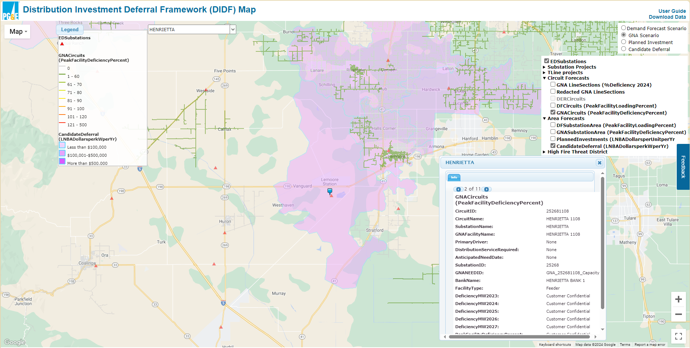

10. Where can participants find data on the Green Valley Bank 4 or Camden 1106 circuits in the DIDF map?
Answer: Green Valley Bank 4 and Camden 1106 are new projects that has not been built yet. To defer the need for these projects, the Grid Needs at Green Valley Bank 3 and Green Valley Bank 2 and Hardwick Bank 1, Henrietta Bank 5, and Camden 1102 should be met for each project, respectively. Please note, customer information is always in respect to the Grid Need that is being addressed (not the name of the project).

11. For the Giffen Bank 2 project, how do Participants obtain more information on the project requirements, including capacity need and event parameters?
Answer: Participants must sign an NDA. The NDA document is posted on the Partnership Pilot webpage.

12. Will there be regular updates available on the amount of reserved capacity for each project before it has been fully subscribed?
Answer: PG&E posts monthly updates on its website.

